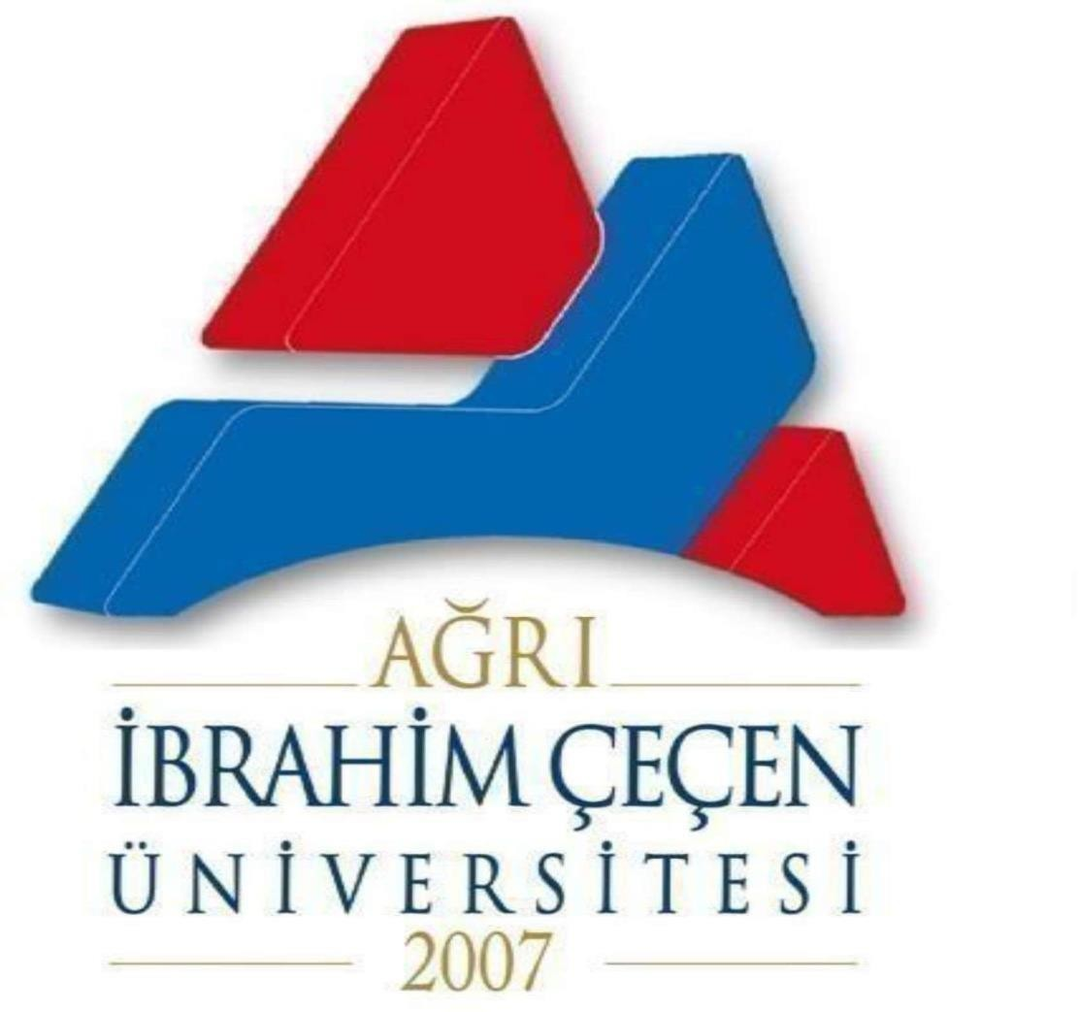
REPUBLIC of TÜRKİYE
AĞRI İBRAHİM ÇEÇEN UNIVERSITY
2023-2024 ACADEMIC YEAR INTERNATIONAL STUDENT ADMISSION GUIDE

1.Application, Placement, Registration and Examination Dates
Application Date: August 28-September 1
Evaluation of the Application: September 4, 2023
Announcement of those who have the right to register online: September 5, 2023
Final Date: September 06-13, 2023
2.Placement and Registration Date for Vacant Quotas:
3.Turkish Proficiency Exam Applications:
Turkish Proficiency Exam Date:

For more information:
Ağrı İbrahim Çeçen University Student Affairs Department:
Adress: Erzurum Yolu Üzeri 4. km, Rektörlük, 04100, Ağrı/ Türkiye
E-mail : ogrenci@agri.edu.tr
Tel : +90 472 215 98 63-216 10 10
Fax : +90 472 215 11 82
Webpage: https://www.agri.edu.tr/detail.aspx?bid=596&tid=15&dil=tr-TR
Coordinatorship of International Relations: Murat GÜRBÜZ
Tel: +90544 731 35 97
E-mail: mugurbuz@agri.edu.tr
Department of Student Affairs (Unit Supervisor): Nalan ERBAY
Tel: +90472 216 10 10
Intercom: 7003
E-mail: ogrenci@agri.edu.tr
II. Application Requirements
Foreign student candidates can study in the first and second education programs of our university at the associate and undergraduate level.
a) To study in the last year of high school or to be a high school or equivalent school graduate
1) Those who are Turkish citizens by birth but have received permission from the Ministry of Interior to renounce Turkish citizenship and their minor children registered in the certificate of renunciation of Turkish citizenship, who certify that they have a Certificate on the Exercise of the Rights Recognized by Law No. 5203,
2) Dual nationals who were foreign nationals by birth and later acquired Turkish citizenship,
3) Turkish nationals who completed the last three years of high school education in a foreign country except TRNC.
4) Those who have TRNC nationality, reside in TRNC and have completed their secondary education in TRNC and have GCE AL exam results.
5) Applications of TRNC nationals who have or will have GCE AL exam results by enrolling and studying in colleges and high schools in other countries between 2005-2010 are accepted,
b) Candidates
1) Turkish nationals (the last three years of high school education in a foreign country other than the TRNC except those who have completed)
2) K.K.T.R. nationals (except those who have completed their entire secondary education in K.K.T.R. high schools and have GCE AL results)
3) Dual nationals, one of whose nationality is Turkish Republic (except those who completed the last three years of high school education in a foreign country other than TRNC)
3) Dual nationals, one of whose nationality is TRNC (except for those who have completed their entire secondary education in TRNC high schools and have GCE AL results and those who have or will have GCE AL exam results by enrolling and studying in colleges and high schools in other countries between 2005-2010).
5) Applications of Turkish nationals who completed their high school education in the Republic of Cyprus are not accepted.
Recognised Exams for Application
1) The evaluation of applications is based on the following exams approved by YÖK. The evaluation criteria of the exams accepted in the application are as follows:
a) TCS (Turkish Republics and Communities Exam): At least 40 points,
b) SATI (Educational Assessment Examination): At least 1000 total points and at least 400 Math points,
c) ACT (American College Test): Math, Science and a total score of at least 20,
ç) GCE (General Proficiency Exam): Candidates who have A level in at least 3 subjects, at least one of which is related to the department applied for, and whose average grades in these subjects are C or above,
d) International Baccalaureate diploma grade of at least 24,
e) German ABITUR exam score maximum 4
f) French Baccalaureate diploma grade of at least 10,
g) Matura diploma degree up to 4,
ğ) The Jordanian and Palestinian Tawjihi at least 70, Lebanese Baccalaureate grade at least 12.
1) Syria Al-Shahada al-Thanawiyya (Syrian Baccalaureate): At least 150 in the score type of the applied program,
h) Iranian high school diploma (Diploma Debirestan): Minimum average of 12/20 and Pishtaneshgahi graduation grade of at least 12/20,
i) Kazakhstan National University Test: At least 60 out of 120,
j) Gaokaonda-University of the People's Republic of China Entrance Exam: At least 400 out of 750 according to the score type of the applied program,
k) Gold, silver and bronze medals from international science, art and sports olympiads, provided that they are recognized as valid by the authorities in Turkey.
(2) Apart from the exams listed above, applicants may be evaluated by Ağrı İbrahim Çeçen University based on their secondary education diplomas or national exams taken in their home countries.
(3) The validity of Abitur, International Baccalaureate, GCE, Taxiki, etc. degrees obtained at the secondary education level is indefinite. However, SATI, ACT and YÖS exams are valid for two years.
(4) Evaluation of applications to academic units that admit students through special talent exams.
It is made according to the criteria in Ağrı Ibrahim Çeçen University special talent exam directives.
5) To have a score of 40 out of 100 in the YÖS exams conducted by Künib and other universities,
Those who have received a Turkish proficiency certificate with a score of 55 and above in the Turkish proficiency exam conducted by Yunus Emre Institute are accepted. Document validity period is 2 years.
III. Application Procedure
(1) Applications must be made to Ağrı İbrahim Çeçen University Student Affairs Department through our website between the dates given above and Ağrı İbrahim Çeçen University Student Affairs Department.
(2) Candidates can apply to maximum 3 programs. These programs are specified in the "Application Form for Overseas Student Admission".
IV. Documents Required for Application:
a) Diploma, Graduation certificate ((Atestat) photocopy)
b) Passport (photocopy)
c) TÖMER exam result certificate (if any) showing the Turkish proficiency level of non-Turkish citizens
Note: Original documents will be requested during registration.
V. Documents Required for Registration
1. Original Diploma (Atestat), (Graduation certificate or Atestat must be approved by the Consulate or Apostilled).
2. Diploma Equivalency Certificate (obtained from Consulates, Provincial Directorates of National Education).
3. Original passport and Turkish translation (notarized).
4. Original and Turkish translation of the transcript (Notarized).
5. Foreign entry and exit printouts of Turkish nationals
6. TÖMER Certificate for non-Turkish citizens
7. 6 photographs
8. Report
NOTE: THOSE WITH MISSING DOCUMENTS WILL NOT BE REGISTERED.
VI. Tuition Fees
AĞRI İBRAHİM ÇEÇEN UNIVERSITY TUITION TABLE FOR 2023-2024, 2022-2023, 2021-2022, AND BEFORE 2020-2021 ACCORDING TO (DBL) OF THE CURRENT SERVICE COST OF INTERNATIONAL STUDENTS WITH CONTRIBUTION SHARE AND TUITION FEE.
 | INTERNATIONAL STUDENTS |  | INTERNATIONAL STUDENTS
 | Students enrolled in 2021-2022 academic year and after |  | Students enrolled in 2020-2021 academic year and before
FACULTY/SCHOOL | FORMAL EDUCATION SECONDARY EDUCATION |  | FORMAL EDUCATION SECONDARY EDUCATION
YEAR AND SEMESTER | 2023-2024 Fall | 2023-2024 Spring | 2022-2023 Fall | 2022-2023 Spring
Faculty of Medicine | 41410,00 | 41410,00 | 41410,00 | 41410,00
Faculty of Pharmacy | 14950,00 | 14950,00 | 14950,00 | 14950,00
Faculty of Education | 5500,00 | 5500,00 | 5500,00 | 5500,00
Faculty of Arts and Sciences (Literature and Social Program) | 5140,00 | 5140,00 | 5140,00 | 5140,00
Faculty of Arts and Sciences (Science Program) | 6850,00 | 6850,00 | 6850,00 | 6850,00
Faculty of Economics and Administrative Sciences | 6200,00 | 6200,00 | 6200,00 | 6200,00
Faculty of Islamic Sciences | 5500,00 | 5500,00 | 5500,00 | 5500,00
Faculty of Islamic Sciences ARABIC | 5500,00 | 5500,00 | 5500,00 | 5500,00
Faculty of Sports Sciences | 5500,00 | 5500,00 | 5500,00 | 5500,00
Faculty of Health Sciences | 5500,00 | 5500,00 | 5500,00 | 5500,00
School of Foreign Languages | 6200,00 | 6200,00 | 6200,00 | 6200,00
School of Tourism Management and Hotel Management | 6200,00 | 6200,00 | 6200,00 | 6200,00
Celal Oruç School of Animal Production | 6200,00 | 6200,00 | 6200,00 | 6200,00
Patnos School of Social Services | 6200,00 | 6200,00 | 6200,00 | 6200,00
Vocational School | 4100,00 | 4100,00 | 4100,00 | 4100,00
Vocational School of Health Services | 4100,00 | 4100,00 | 4100,00 | 4100,00
Vocational School of Civil Aviation | 4100,00 | 4100,00 | 4100,00 | 4100,00
Patnos Vocational School | 4100,00 | 4100,00 | 4100,00 | 4100,00
Eleşkirt Vocational School | 4100,00 | 4100,00 | 4100,00 | 4100,00
Doğubeyazıt Ahmed-i Hani Vocational School | 4100,00 | 4100,00 | 4100,00 | 4100,00
Institute of Postgraduate Education | 4100,00 | 4100,00 | 4100,00 | 4100,00

